Online Exam System

Mohammad Minhazul Haq

Student ID : **0805051**

Group partners: 0805056, 0805057

Project Supervisor:

Mahfuza Sharmin

Lecturer, CSE, BUET

rhythm.cse.buet@gmail.com

**Module description**

**User subsystem**

**Admins** are the top-most administrator of Online Exam System. They are identified by Admin_ID. Each admin must have name, address, email, mobile no, profile picture and registration date-time.

**Teachers** are identified by Teacher_ID. They have name, institution, department, designation, address, email, mobile no, profile picture and registration date-time.

**Students** are identified by Student_ID. They have name, institution, department, roll, level, term, session, sex, date of birth, address, email, mobile no, profile picture and registration date-time.

All of these users must enter their username and password to login the Online Exam System site.

**Financial subsystem**

Any students who wants to be registered needs to pay us. They can choose any of the **Package**s existed. Students will pay us through **Credit Card.** They need to enter credit card serial and pin code. Then we’ll check if there exists the required amount, if yes then we’ll cut the required amount. Packages will be valid for limited days, after the expiration user needs to renew his/her account by paying again.

There will be **scholarship**s for the students who obtained required CGPA for that scholarship. One department may have zero/one/more scholarships. Head of the department only can add/edit any scholarship for his/her department. When a student gets a scholarship and wants to transact money to his/her account, then he/she should enter the Credit Card Serial and Pin Code. Then the amount will be added to that credit card.

**Input forms**

**New teacher form :**

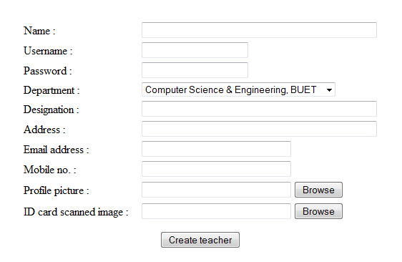

**User login form :**

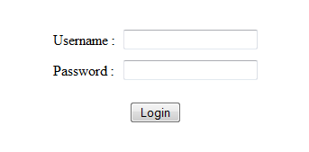

**New student form :**

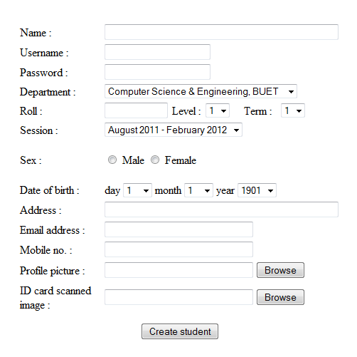

**New package form :**

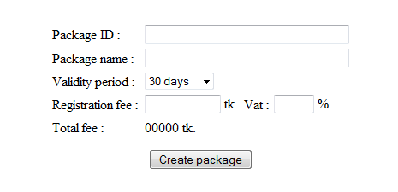

**New scholarship form :**

